Mini Project

**Title**: **Analysis on Heart Disease**

* Krish P Prakash

**Outcomes**:

1. Age Group with Maximum Heart Disease Prevalence
2. Gender-wise Heart Disease Prevalence
3. Heart Disease Probability by Chest Pain Type
4. Average Cholesterol Level for Patients with and without heart disease
5. Average Maximum Heart Rate (thalach) for patients with and without heart disease

**Dataset Used**:

* Link:

<https://www.kaggle.com/code/farzadnekouei/heart-disease-prediction/input>

* Dimensions:

Dimensions of the dataset: (303, 14)

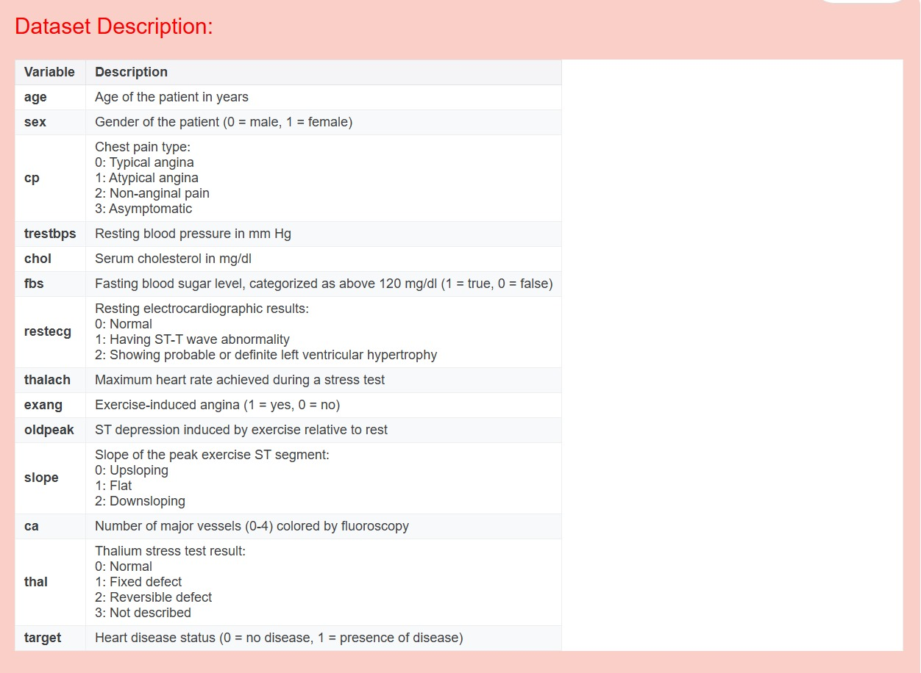

**Details of the implementation**:

* Python Libraries:
  + - 1. Numpy
      2. Pandas
      3. Matplotlib
      4. Seaborn
* Prominent Functions:
  + pd.read_csv
  + .info()
  + .shape()
  + .describe().T
  + .isnull().sum()
  + .quantile(0.25/0.75)
  + sns.countplot()
  + sns.heatmap()
  + plt.subplot()
    - plt.histplot()
    - plt.boxplot()
  + plt.pie()
  + etc.